Supplementary Information

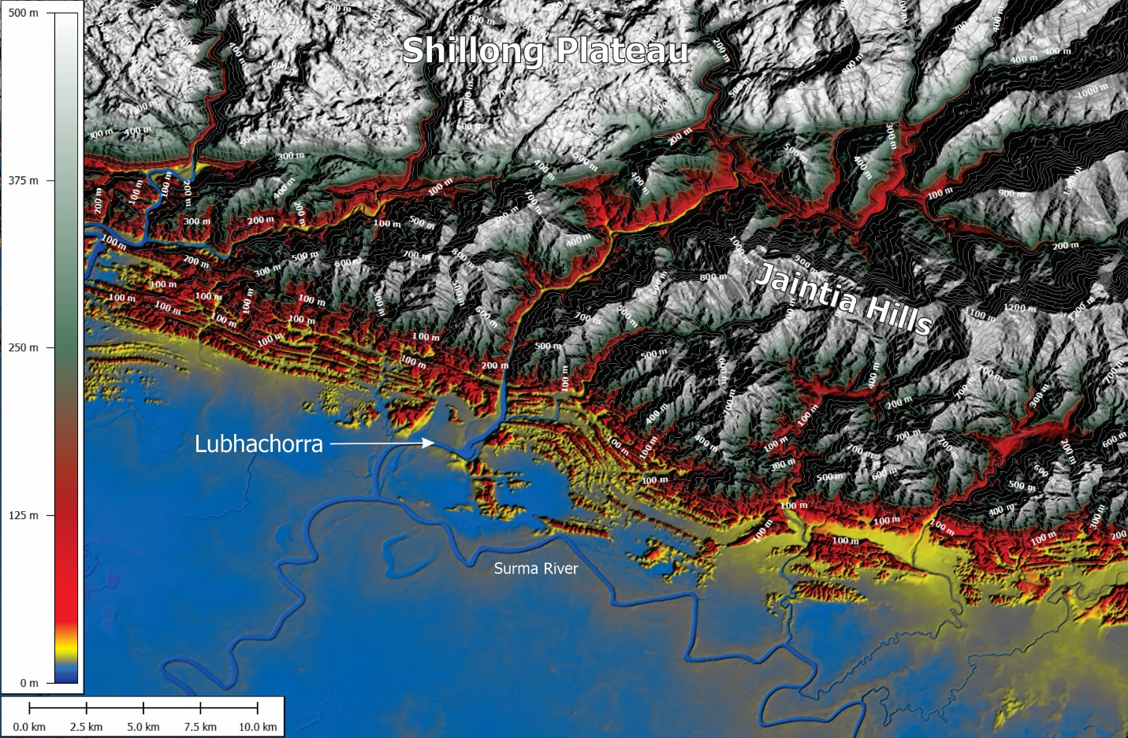

Figure SI1: Topography of the study area
Digital elevation model of the area plotted using FathomDEM¹. As the river exits the Jaintia Hills, its slope changes from c. 5° to a floodplain gradient of c. 0.4°.

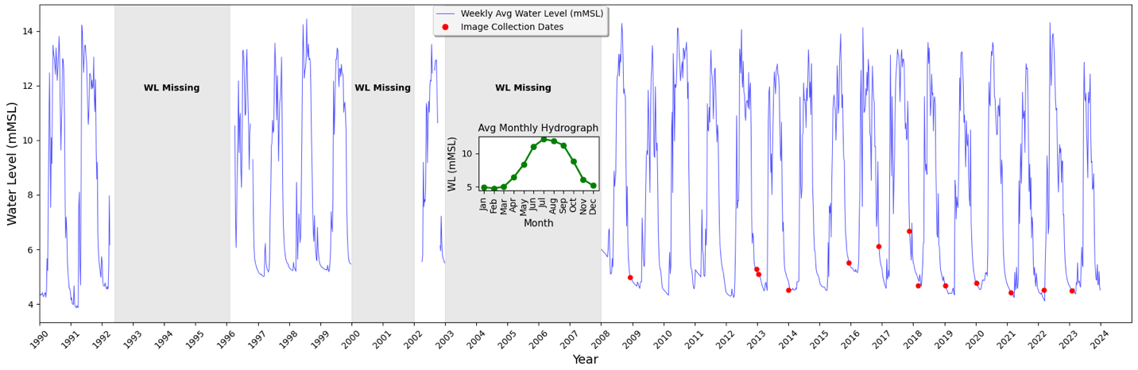
Figure SI2: Seasonal and interannual variability of water levels and image acquisition timing at the Lubhachorra gauge.
Hydrograph plotted using weekly-averaged water levels at Lubhachorra gauge, 1990 - 2024, highlighting seasonal fluctuations and data gaps (gray-shaded regions). Red dots denote dates of image collection (see Table SI1). The inset graph displays the average monthly hydrograph, illustrating the typical seasonal pattern with peak flows during July-September and stable, low water levels during December-March. This consistency in dry-season water levels facilitated analysis of gravel mining impacts on the riverbed.
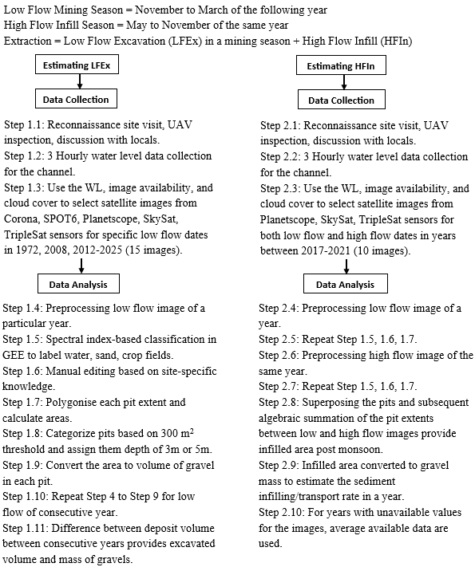
Figure SI3: Flow chart detail the stages of image processing and derivation of estimates of gravel extraction, sediment transport rate and number of workers housed in temporary barracks.
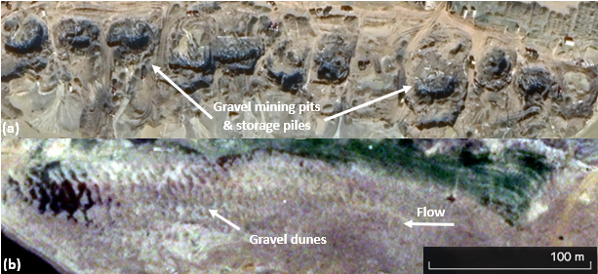

Figure SI4: Google Earth Maxar images of the active channel at Lubhachorra.
a) January 7th, 2019, and b) March 26th, 2024, illustrating recovery of geomorphology in the active channel over a period of 5 years, and how the mining pits evident in a) have been infilled by sedimentation. Note the presence of gravel dunes in b).

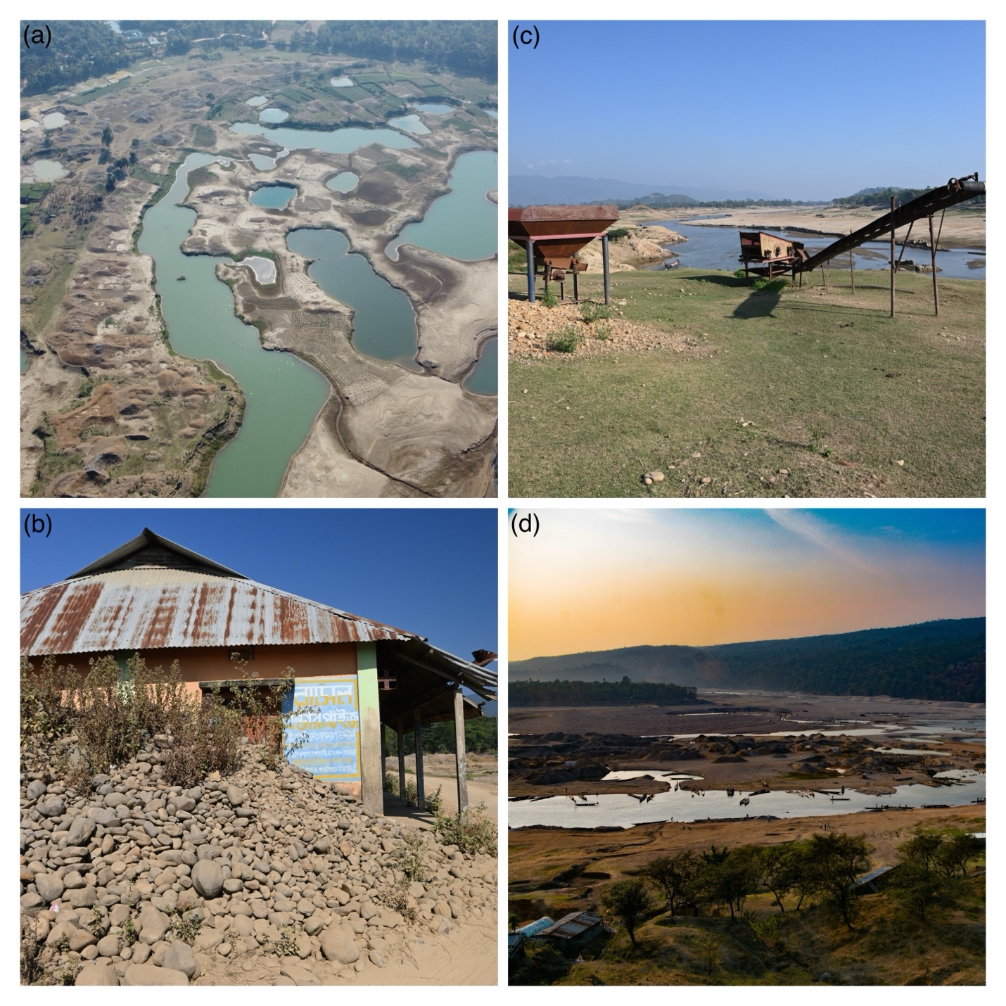
Figure SI5: Field photographs of floodplain degradation, infrastructure abandonment, and channel recovery associated with gravel mining at Lubhachorra and Jaflong.
(a) Aerial view of floodplain at outside of meander bend at Lubhachorra, January 2023, following intensive gravel extraction, showing extensive excavation pits remaining on the floodplain. (b) The office of a gravel extraction company at Lubhachorra, January 2023, closed after the ban on mining was enacted in 2021, and with piles of unsold gravel remaining outside. (c) View from downstream looking upstream in Lubhachorra, January 2023, showing evidence for the recovery of the natural morphology of the channel in the background, as well as abandoned and rusting gravel sorting machinery on the adjacent floodplain. (d) View of the river valley at Jaflong, March 2015, showing large-scale mining of gravels in the upper region of the channel. Photo credits: a) Md Sadiul Alam Chyon; b-d) – Jim Best.

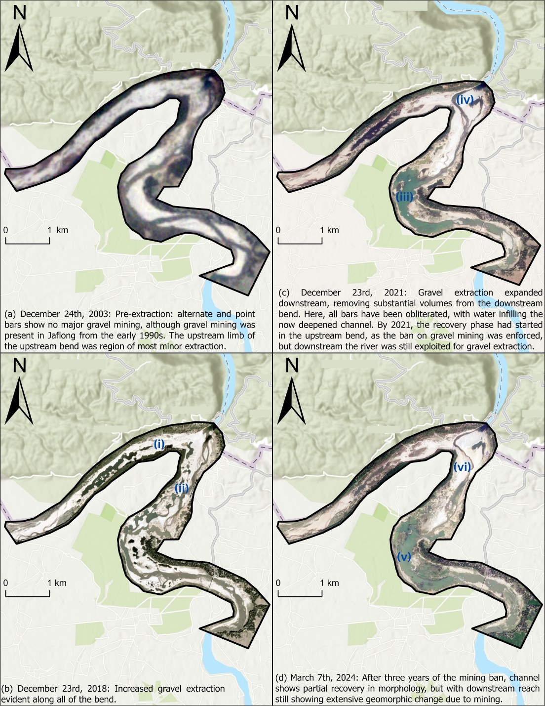
Figure SI6: Spatiotemporal evolution of gravel and sand mining and associated channel recovery at Jaflong, 2003–2024.
Remote sensing images of gravel and sand mining at Jaflong (see Fig. 2 inset map for location) from 2003 to 2024. More extensive mining likely commenced in the upstream and downstream parts of the acute bend (see labels i) and ii in b)) in c. 2008, and with the locus of mining shifting downstream over time (see label iii) in c)) as gravel resources were depleted in the upstream reach. The lack of mining in the upstream reach following depletion of resources, together with the ban on mining in 2021, allowed some recovery in the morphology of the upstream channel (see labels iv) and v) in c) and d)), although the downstream reach still shows signs of extensive extraction in 2024 (see label vi) in d)) as sediment has yet to be transported into this region. The more significant extraction of gravel at Jaflong, as compared to Lubhachorra, and its more extensive impact on the channel morphology, results in the period of channel recovery being longer here as compared to Lubhachorra (e.g. compare 2024 images in Figs 2f and 4d).

Satellite | Spatial Resolution (meters) | Image Capture Date | Water Level (meters above Mean Sea Level, mMSL)
Corona | 1 | 1/26/72 | Not available
SPOT5 | 10 | 12/15/2008 | 4.976
SPOT6 | 1.5 | 12/24/2012 | 5.286
SPOT6 | 1.5 | 1/19/2013 | 5.096
SPOT6 | 1.5 | 1/4/2014 | 4.516
SPOT6 | 1.5 | 12/9/2015 | 5.516
Triplesat | 0.8 | 11/24/2016 | 6.128
Triplesat | 0.8 | 11/11/2017 | 6.672
Planetscope | 3 | 1/13/2018 | 4.682
Triplesat | 0.8 | 1/9/2019 | 4.676
Triplesat | 0.8 | 1/12/2020 | 4.776
Triplesat | 0.8 | 2/16/2021 | 4.416
Triplesat | 0.8 | 3/8/2022 | 4.506
Triplesat | 0.8 | 2/3/2023 | 4.49
Skysat | 0.5 | 3/2/2024 | 4.716
Planetscope | 3 | 11/30/2017 | 7.136
Planetscope | 3 | 11/30/2018 | 5.956
Planetscope | 3 | 11/30/2019 | 6.086
Planetscope | 3 | 11/30/2020 | 8.086
Planetscope | 3 | 11/30/2021 | 13.796
Planetscope | 3 | 11/30/2022 | 8.206
Planetscope | 3 | 11/30/2023 | 4.766
Planetscope | 3 | 11/30/2024 | Not available
Table SI1: Types of satellite and dates of images for remote sensing analysis used herein, with the corresponding water level at Lubhachorra.

1. How has your life changed after gravel extraction was stopped? | 95% reported economic hardship and unemployment. 48 people (of 55; 87%) shifted to agriculture or odd jobs, with some resorting to illegal activities due to lack of work.
2. Do you think the quarry activity was stopped because of environmental damage? | Few respondents (5 out of 55; 9%) acknowledged environmental damage as a reason. Most were unsure or cited economic, regulatory, or governmental factors as primary reasons for the closure.
3. Could you please tell me about the infrastructural development in your area during active mining? | 14% of respondents noted improvements in local infrastructure and economic growth, such as new businesses and better roads. These developments often faded post-mining.
4. What work do people now perform to survive? | 33% mentioned a shift to agriculture, whilst others indicated migration to cities or abroad in search of work. The transition has been challenging and insufficient for many.
5. Have you applied to higher authorities to re-open the gravel pits? | 73% have petitioned authorities to reopen the mines, reflecting a desire to return to previous economic conditions, but these efforts were often met with silence or refusal.
6. What were the major changes to the village after the cessation of mining? What has happened to the land and river? | 88% described significant economic decline, increased poverty, and decreased commerce. Some land use changes were observed, but environmental recovery was slow or negligible.
7. Did the mining operations lead to any economic disadvantages for the local community, such as job losses in other sectors or increased cost of living? | 80% reported that the cessation of mining led to an economic downturn, impacting job availability and overall living standards.
8. Were there any health or safety issues for the local community associated with the mining operations due to sound, air, or water pollution? | 90% did not report significant health issues from mining, with 10% raising issues such as respiratory problems. Most concerns centered on economic and social impacts rather than direct health effects.
Table SI2: Semi-structured survey questionnaire and summary of responses of Lubhachorra residents, February 3- February 12, 2024.

Supplemental References List
[1] Uhe, P., Lucas, C., Hawker, L., Brine, M., Wilkinson, H., Cooper, A., Saoulis, A.A., Savage, J., and Sampson, C. (2025). FathomDEM: An improved global terrain map using a hybrid vision transformer model. Environ. Res. Lett. 20, 034002. https://doi.org/10.1088/1748-9326/ada972.

